

**KABARAK UNIVERSITY**

**TOPIC:** Enhancing Environmental Conservation Efforts in Kenya: A Web-Based Platform Connecting Activists with Local Communities and Institutions for Sustainable Impact

**RESEARCH PROPOSAL**

**COMP 411**

**MWIRIGI RYAN MUNENE**

Submitted To The School Of Science, Engineering And Technology Of Kabarak University In Partial Fulfilment Or Award Of Bachelor Of Science In Computer Science.

**NOVEMBER 2023**

# 

# DECLARATION

I declare that this project is my original work and according to the best of my knowledge, it has never been presented in any other institution of higher learning for an award.

Signature Date

……………………………………… ……………………………………………

MWIRIGI RYAN MUNENE

CS/MG/1251/09/20

# RECOMMENDATION

This project is submitted for examination with my approval as a university supervisor.

**Signature** **Date**

……………………………………… ……………………………………

MERCY GACHOKA

DEPARTMENT OF COMPUTER SCIENCE AND INFORMATION TECHNOLOGY

KABARAK UNIVERSITY.

# 

# DEDICATION

I would like to dedicate this project to my loving parents who have supported me in every way possible and most of all to my God who has given me the opportunity to be able to work on the project.

# ACKNOWLEDGEMENT

I acknowledge the efforts of my lecturer Mrs. Mercy for her guidance throughout the study.

# ABSTRACT

This abstract introduces a groundbreaking initiative, the Activist Connect Web-Based App, designed to empower environmental conservation activists and enthusiasts in Kenya. Utilizing cutting-edge web technologies, the platform connects users with local landowners and institutions committed to environmental conservation, with a specific focus on activities like tree planting. Through advanced geolocation services, users can effortlessly identify suitable spaces for eco-friendly endeavors, such as tree planting, waste collection, and weeding. The research adopts a robust Design Science Research methodology, emphasizing iterative design, development, and assessment to create an innovative technological solution. Key components of the research include identifying user requirements, developing the Activist Connect Web-Based App, and validating its effectiveness through user testing and feedback. The iterative nature ensures continuous improvement in the tool's performance, usability, and user satisfaction. The anticipated outcomes of this research include the creation of a user-friendly and effective Activist Connect Web-Based App, providing a valuable contribution to the field of environmental conservation. The platform aims to elevate environmental awareness, encourage community participation, and drive tangible conservation outcomes. Through its intuitive interface and localized content, the app seeks to make a significant impact on Kenya's environmental conservation initiatives, instilling a sense of collective responsibility and encouraging enduring sustainable practices in the region.

Keywords: Activist Connect, Web Application (web app), Environmental conservation, Climate Activist, Geolocation Services, Sustainability Education, Design Science Research.

## Table of Contents

DECLARATION I

RECOMMENDATION II

DEDICATION III

ACKNOWLEDGEMENT IV

ABSTRACT V

Table of Contents 1

List of figures 3

CHAPTER ONE 4

INTRODUCTION 4

1.1 Introduction 4

1.2 Background of the Study 4

1.3 Statement of the Problem 5

1.4 Research Objectives 5

1.5 Research Questions 6

1.6 Scope and Limitation 6

1.7 Basic Assumptions 7

1.8 System Modules 7

1.8.1 Activist Profile and Project Management Module 7

1.8.2 Project Management: 8

1.8.3 Collaboration and Communication: 8

1.8.4 Location-Based Features: 8

1.8.5 Chatbot Module: 8

CHAPTER 2 10

LITERATURE REVIEW 10

2.1 Introduction 10

2.1.2 Climate Change 10

2.2 Tree Planting Initiatives and Social Outcomes 11

2.3 Institutional Design and Ecological Outcomes 15

2.4. Community Capacity and Tree-Planting Projects 15

2.5. Urban Trees and Environmental Knowledge 15

2.6 Household Tree Planting Determinants 16

2.7 Tree Species and Growth Phases in Household Tree Planting 17

2.8 Tree Planting in Kenya 19

2.8.1 Time of planting 19

2.8.2 Page preparation 19

2.8.3 Care of seedlings 19

2.8.4 How to plant 20

2.8.5 Care after planting 20

2.9 Design Framework 20

CHAPTER 3 24

RESEARCH METHODOLOGY 24

3.1 Introduction 24

3.2 Design Science Research 24

3.2.1 Problem Identification and Motivation 25

3.2.2 Definition of Objectives for a Solution 26

3.2.3 Design and Development: 27

3.2.4 Demonstration: 28

3.2.5 Evaluation 28

3.2.6 Communication of Results: 29

3.3 Study Location and Population 29

3.4 Population of the Study 30

3.5 Sampling Procedure and Sample Size 30

3.5.1 Data Collection Procedure 30

3.6 Unified modelling language (UML) diagrams 31

Use-case Diagram 31

Sequence Diagram 32

3.6.1 Context diagram 33

3.6.2 Dataflow diagram 34

3.7 Software Development Methodology 35

3.7.1 Programming Methodology 36

3.7.2 Selection of Technologies and Languages: 36

CHAPTER 4 38

CONCLUSION 38

CHAPTER 5 39

RECOMMENDATION 39

References 40

Appendices 41

Questionnaire (google form) 41

Workplan 44

Activity 45

Cost 45

## List of figures

Figure 1 The tree life-cycle 18

Figure 2 Activist connect wireframe 22

Figure 3 The web application architecture 23

Figure 4 The Design Science Approach 25

Figure 5 Activist Connect Use-case diagram 31

Figure 6 Activist Connect Sequence diagram 32

Figure 7 Context Diagram 33

Figure 8 Activist connect data flow diagram 34

Figure 9 Dev-ops visualization 36

Figure 10 Gannt Chart 45

Figure 11 Budget 45

# CHAPTER ONE

# INTRODUCTION

## Introduction

Environmental conservation stands at the forefront of global concerns, particularly in regions facing pressing ecological challenges like Kenya. The delicate balance between human progress and preserving natural habitats demands innovative, inclusive, and efficient approaches. This research proposal introduces a groundbreaking initiative titled "Enhancing Environmental Conservation Efforts in Kenya: A Web-Based Platform Connecting Activists with Local Communities for Sustainable Impact." The project recognizes the urgency to facilitate seamless collaboration between passionate environmental activists and local communities, emphasizing tree planting as a pivotal conservation activity. In response to the critical need for streamlined and accessible solutions, this research aims to develop a state-of-the-art web-based platform. By harnessing the power of modern technology, this platform seeks to bridge the gap between conservation enthusiasts and landowners, ensuring a harmonious alliance in the pursuit of sustainable environmental practices. This chapter provides a comprehensive overview of the background, the problem statement, research objectives, research questions, scope, limitations, and basic assumptions, laying the groundwork for a detailed exploration of this transformative endeavour in the subsequent chapters.

## 1.2 Background of the Study

The global imperatives of environmental conservation and climate change mitigation have become increasingly urgent, casting a spotlight on the critical role that technology can play in addressing these challenges. In the Kenyan context, the multifaceted issues of deforestation, the imperative need for extensive tree planting, and the active engagement of communities in sustainable practices have emerged as focal points demanding immediate attention. The evolving environmental landscape of Kenya requires a dynamic and inclusive approach to conservation efforts.

Amidst these challenges, the proposed Environmental Conservation Web-Based App emerges as a beacon of innovation and collaboration. It endeavors to fill crucial gaps by connecting dedicated conservation activists not only with local landowners but also with institutions committed to environmental stewardship. This holistic approach creates a symbiotic relationship that fosters tree planting initiatives and cultivates environmental awareness. The digital platform is envisioned not only as a facilitator of practical, on-the-ground projects but also as a hub for knowledge exchange, empowering communities with information on sustainable practices.

Moreover, the app aims to leverage geolocation services, providing users with real-time data on available spaces for tree planting, waste collection, and other conservation activities. By integrating technology with environmental activism, the platform seeks to inspire a sense of collective responsibility and action, forging a pathway towards a more sustainable and resilient ecological future for Kenya. In this way, the Environmental Conservation Web-Based App aspires to be a catalyst for transformative change, harnessing the power of digital connectivity to address pressing environmental concerns at the local level.

## 1.3 Statement of the Problem

In the context of Kenya's environmental landscape, a significant disparity exists between the urgency of conservation efforts and the available streamlined platforms connecting conservation enthusiasts and local communities. Despite the growing awareness of environmental issues, there remains a critical gap in the accessibility of cohesive, technology-driven solutions that facilitate meaningful collaboration between passionate environmental activists and landowners. This gap hampers the efficient coordination of tree planting initiatives and other vital conservation activities. Moreover, the absence of a centralized platform exacerbates the challenges faced by both conservationists and landowners, leading to inefficiencies, lack of standardized communication channels, and hindered collective action.

Additionally, the existing methods of environmental conservation initiatives lack a comprehensive and integrated approach, leading to fragmented efforts and suboptimal outcomes. The absence of a dedicated digital platform tailored to the unique needs of Kenya's environmental conservation sector further exacerbates the problem. Traditional methods of communication and collaboration prove to be insufficient in harnessing the collective potential of both activists and local communities. These challenges highlight the pressing need for an innovative, user-friendly, and accessible web-based platform that bridges this gap, fostering a sense of community, promoting educational awareness, and empowering stakeholders to engage actively in sustainable tree planting initiatives. Addressing these challenges is fundamental for fostering an environment where environmental conservation can thrive and where the collective efforts of activists and communities can make a substantial and lasting impact.

## 1.4 Research Objectives

The primary objectives of this research are as follows:

1. To identify the key requirements and features of an efficient and effective web-app for connecting conservationists with institutions and local land owners.
2. To design an intuitive and user-friendly interface for the web-app, ensuring accessibility to users of varying backgrounds.
3. To develop a user-friendly web-based app facilitating the connection between conservation activists with easily accessible institutions and local landowners for tree planting initiatives.
4. To test the web-app’s effectiveness in fostering collaboration between the various institutions and land owners with the conservationists.

## 1.5 Research Questions

The research will address the following questions:

1. What are the key requirements and features essential for an efficient and effective web-app connecting conservationists with institutions and local landowners for environmental conservation initiatives?
2. How can the we-app be designed to ensure an intuitive and user-friendly interface, making it accessible to users with diverse backgrounds and technical expertise?
3. What user-friendly features and functionalities should be incorporated into the web-based app to facilitate seamless connections between conservation activists, institutions, and local landowners for tree planting and environmental conservation efforts?
4. What is the impact of the web-app in fostering collaboration among conservationists, institutions, and landowners?

## 1.6 Scope and Limitation

The study focuses on the development and implementation of the web-based app specifically for tree planting initiatives in Kenya. While the app may have the potential to address broader environmental conservation issues, this research will concentrate on tree planting activities and related educational efforts within the defined scope. Limitations include potential challenges related to internet connectivity in remote areas and the willingness of landowners to participate in the initiative.

## 1.7 Basic Assumptions

The research operates on the following assumptions:

- Users have access to basic internet-enabled devices, including smartphones or computers.

- Landowners are willing to participate and provide accurate information about available spaces for tree planting.

-Users are motivated to engage in environmental conservation activities, particularly tree planting initiatives, and are open to utilizing the web-based app for these purposes.

By addressing these components, the research provides a comprehensive overview of the project's context, challenges, objectives, and parameters, setting the stage for the development and evaluation of the Activist Connect App for tree planting initiatives in Kenya.

## 1.8 System Modules

The Activist Connect web application comprises various interlinked modules, each serving a distinct yet interconnected purpose. These modules collectively contribute to the seamless functioning of the platform, fostering collaboration and efficiency in environmental conservation initiatives.

## 1.8.1 Activist Profile and Project Management Module

The cornerstone of Activist Connect, this module revolves around empowering environmental activists and facilitating project management for organizations involved in conservation efforts. It encompasses the following key functionalities:

User Profiles:

- User Registration: Activists can initiate their journey by registering on the platform, providing essential information such as name, contact details, and areas of expertise.

- Profile Customization: Activists have the flexibility to tailor their profiles, adding details about their environmental interests, experiences, and skills. Personalization is further enhanced by the option to upload a profile picture.

## 1.8.2 Project Management:

- Project Listing: Environmental organizations can showcase their conservation projects on the platform, detailing project specifics, goals, and required skills/resources.

- Project Search and Application: Activists can seamlessly search for projects aligned with their interests, location, and skills. The application process is user-friendly and straightforward.

- Project Assignment: Organizations can efficiently review applications and assign activists to specific projects, ensuring a transparent and equitable assignment process.

- Task Management: Projects are broken down into tasks with clearly defined responsibilities. Activists can monitor their assigned tasks and update progress.

## 1.8.3 Collaboration and Communication:

- Messaging and Discussion Forums: The integrated messaging system facilitates smooth communication between activists and organizations. Discussion forums cater to both project-specific and general environmental discussions.

- File Sharing: Activists and organizations can share documents, images, and other project-related files, fostering collaboration and information exchange.

## 1.8.4 Location-Based Features:

- Geo-Tagging: Activists can tag their location, enabling them to discover local projects. Organizations, in turn, can identify suitable lands for conservation activities.

## 1.8.5 Chatbot Module:

- Essential Information: A Chatbot interface is integrated into the platform, offering vital information to users. For instance, it provides guidance on the types of tree species suitable for planting in specific locations, ensuring informed decision-making in environmental initiatives.

Benefits:

- Efficient Resource Allocation: Skills and resources are optimized for maximum impact, ensuring projects are staffed with activists possessing relevant expertise.

- Community Building: The platform fosters a vibrant community of like-minded individuals passionate about environmental causes, promoting collaboration and knowledge exchange.

- Transparency and Accountability: Transparent project assignment and communication build trust among activists and organizations. The rating and review system ensures accountability.

- Localized Impact: Geo-tagging and local event notifications encourage activism at the grassroots level, promoting local environmental initiatives.

# CHAPTER 2

# LITERATURE REVIEW

## 2.1 Introduction

The foundation of any meaningful research endeavour lies in understanding the existing body of knowledge within the field. In the context of environmental conservation and technological innovation, an extensive exploration of the literature is imperative to contextualize the current project. This chapter delves into a comprehensive review of relevant literature, aiming to provide a nuanced understanding of the interplay between environmental conservation efforts and digital platforms. By examining prior research, theoretical frameworks, and practical applications, this literature review seeks to identify gaps in existing knowledge and elucidate the theoretical underpinnings that guide the present study.

The literature review endeavours to explore a myriad of topics ranging from environmental conservation strategies and sustainable practices to the integration of technology in conservation initiatives. Additionally, it examines the role of web-based platforms in fostering community engagement and knowledge dissemination. By synthesizing insights from various scholarly works, this chapter aims to draw connections between theoretical concepts and real-world applications, offering a foundation upon which the current research project builds. Through this exploration, the study strives to identify best practices, innovative approaches, and potential challenges faced by previous researchers and practitioners, thereby informing the methodology and guiding the development of the Environmental Conservation Web-Based App for Kenya.

## 2.1.2 Climate Change

Climate Change refers to alterations in a location's typical weather conditions, categorized as mild, varying with seasons, warm, and/or wet. However, there is conclusive evidence indicating a shift from the typical weather pattern to a harmful trend, negatively impacting the environment and ecosystems, both living and non-living.

The Earth, positioned 149,600,000 kilometres from the sun, is surrounded by an atmosphere mainly composed of nitrogen and oxygen. Greenhouse gases, including carbon dioxide, ozone, and water vapor, help warm the atmosphere by reflecting radiation from the Earth's surface. The Greenhouse Effect, described as the warming of the Earth's surface due to air pollution by gases, is currently unintentionally intensifying, leading to climate shifts and Polar Ice Caps melting (Matawal & Maton, 2013)

Research since the 1980s indicates that industrial pollutants like chlorofluorocarbons (CFCs) are causing holes in the ozone layer, particularly over the Antarctic. Climate change, seen globally, negatively impacts all life forms, causing land degradation, fresh water shortages, food insecurity, global warming, flooding, inadequate housing, and challenges in accessing healthcare (Matawal & Maton, 2013)

While the Greenhouse Effect is natural and essential for life, the intensification of this effect due to human activities, such as burning fossil fuels and deforestation, leads to global warming. Carbon dioxide (CO2) plays a crucial role, with human activities disrupting the natural cycle. (Beniston, 2010)For instance, the burning of fossil fuels releases CO2 faster than the rate it is naturally removed through sedimentation, causing a rise in atmospheric carbon dioxide concentrations (Royal Society, n.d.).

The continued release of greenhouse gases will exacerbate climate change, significantly raising global average surface temperatures and altering regional climates. The most compelling evidence of surface warming comes from thermometer records dating back to the late 19th century. The recent decade (2010–2019) is the warmest recorded, and the period from 1989 to 2019 is likely the warmest 30-year span in more than 800 years in terms of Earth's average surface temperature (Royal Society, n.d.).

## 2.2 Tree Planting Initiatives and Social Outcomes

Urban areas, including those in Kenya, have increasingly turned to tree planting initiatives to address environmental concerns and enhance social well-being. Research on urban tree planting projects has shown a variety of social outcomes. Previous studies (Sommer et al., 1994a) have indicated that individuals engaged in tree planting activities tend to be more satisfied with trees planted in their yards, emphasizing the positive impact of such initiatives on individual satisfaction. Moreover, collective tree planting efforts have been linked to higher levels of satisfaction compared to individual efforts (Sommer et al., 1994b). These findings highlight the potential of tree planting programs to not only enhance the urban environment but also positively influence individual attitudes and community cohesion.

When Patel et al. (1995) examined the choices made by households regarding tree cultivation, they discovered that farmers do respond to incentives for planting trees and that tree cultivation competes favourably with other production activities. They attributed the variations among farm households in this context to differences in factor costs, influenced by varying factor endowments and poorly functioning factor markets. Similarly, Mekonnen (1998) investigated tree cultivation decisions among households in Ethiopia, distinguishing between two broad tree categories: all trees and eucalyptus trees. His findings revealed that family size, gender, education, and livestock ownership significantly impact households' tree planting behavior. Moreover, households with a higher proportion of male labor, greater income, and an increased share of off-farm earnings are more inclined to engage in tree cultivation.

Amacher et al. (2004) delved into tree planting practices in Tigrai, Ethiopia, focusing on two species groups: eucalyptus and other trees. Similar to Mekonnen, they differentiated between agricultural land and microdam sites. Their research highlighted the significance of diseases and microdams as key factors influencing tree planting. Additionally, they demonstrated a substantial substitution effect between tree planting and agricultural residues, particularly on privately owned land.

Examining tree planting within customary tenure systems in Malawi, Hansen et al. (2005) explored how gender-specific variations in land tenure rights, influenced by marriage and inheritance patterns, affected tree-planting behavior. Their study revealed that tree planting by married women is not necessarily encouraged by matrilocal marriage patterns, and tree planting by men might even be discouraged by such arrangements. Interestingly, a high incidence of unmarried women was associated with increased tree planting by women.

In a study focusing on Bangladesh, Salam et al. (2000) probed into the motivations behind farmers' tree planting practices, emphasizing homestead agroforestry. They found that economic factors hold more sway than ecological factors in the decision to plant trees. Surprisingly, even in situations of fuelwood scarcity, the decision to plant trees is not solely driven by wood substitutes like animal manure and agricultural residues. Meanwhile, Nibbering (1999) conducted a historical analysis of economic and institutional changes' impact on tree planting in the deforested farmlands of Java, Indonesia. Nibbering argued that a government-initiated tree-planting campaign provided vital incentives, fostering a critical mass of farmers adopting tree cultivation. However, Dewees (1995) contested the effectiveness of the government's tree-planting bonus scheme in Malawi. He highlighted the scheme's high administrative costs and limited impact. Dewees emphasized that household fuelwood demand and market prices are crucial determinants influencing subsistence farmers' decisions to engage in tree planting endeavors.

In the study conducted by Scherr (1995) in western Kenya, three key observations were made: firstly, agroforestry practices historically evolved in response to intensified land use; secondly, diverse livelihood strategies and resource limitations led to varied choices of agroforestry practices on specific farms; and thirdly, farmers' adoption of agroforestry technologies was influenced by associated risks, particularly with new technologies.

Emtage and Suh (2004) investigated the socioeconomic factors affecting smallholder tree planting and management intentions in Leyte province, the Philippines. Their findings indicated that household needs for timber, house construction materials, and other domestic consumption primarily drove tree planting. Importantly, their analysis focused on household circumstances rather than community factors, emphasizing the individual household's influence on tree planting and management activities, although they didn't specify tree species.

Regarding the connection between tree planting/resources and rural livelihoods, trees like timber, fuelwood, fodder, and fruits directly meet household necessities. Additionally, tree planting allows efficient labor utilization, offering households an alternative means of accumulating capital, increasing cash income, and diversifying household economies. Nibbering (1999) argued that the combined benefits of tree cultivation outweighed the gains from expanding annual crop production in deforested areas.

Certain studies highlighted the profitability of eucalyptus trees in northern Ethiopia, with farmers realizing substantial returns on investments. Kidanu (2004) demonstrated that planting eucalyptus trees as field boundaries stabilized the livelihoods of resource-poor farmers, enhancing their income and food security. A short rotation of a eucalyptus-based agroforestry system in waterlogged highland vertisols in Ethiopia could meet wood demand without significant nutrient depletion or crop yield loss.

Holden et al. (2003) utilized a bio-economic model to explore the potential of planting eucalyptus trees in the Amhara region of Ethiopia, aiming to alleviate poverty. They found that planting eucalyptus on private lands unsuitable for crops substantially reduced poverty in these areas. Salam et al. linked tree planting, especially homestead agroforestry, to overall household income improvement and rural poverty alleviation. They argued that tree planting on homesteads could double overall household income compared to arable crops.

Arnold et al. (2006) highlighted the significance of fuelwood production, selling, and trading as substantial sources of household income. Commercial activities involving wood fuels provided supplemental, transitional, or occasional income for some households and constituted the primary income source for others. Additionally, these activities generated working capital for new agricultural or other ventures and fulfilled the subsistence need for fuelwood.

In summary, the literature review reveals gaps in knowledge regarding rural afforestation and tree planting, emphasizing the necessity for in-depth economic and empirical analyses at the household level. Furthermore, understanding specific tree species preferences, purposes, and attributes among rural households remains limited. Trees play diverse roles in rural livelihoods, offering significant economic and ecological benefits for poor farmers. However, the contribution of trees to livelihoods varies across species, warranting further thorough investigation and analysis.

## 2.3 Institutional Design and Ecological Outcomes

Institutional arrangements significantly influence the ecological outcomes of tree planting projects. Effective management of collectively-managed resource systems, such as urban trees, depends on well-designed institutions (Ostrom, 2005). Previous research (Gibson, McKean, and Ostrom, 2000) has established that sustainable outcomes are achieved when communities design their own rules and effectively monitor and enforce these rules. Applying these principles to urban tree planting, institutions can be viewed as strategies, rules, and norms governing tree planting, management, and removal. Institutions that align with local contexts and allow communities to create their own rules (Mincey and Vogt, in review) are crucial for the successful ecological outcomes of urban tree planting projects.

## 2.4. Community Capacity and Tree-Planting Projects

Community capacity, including adaptive capacity and resilience, is fundamental in ensuring the long-term success of urban tree planting initiatives. Community capacity is determined by factors such as participation, leadership, resources, social networks, and trust (Goodman et al., 1998). Tree planting projects serve as collective actions that build social capital, trust, and reciprocity among individuals (Adger, 2003). Moreover, these projects can enhance neighbourhood ties and promote a sense of community (Lewicka, 2005). Understanding the link between tree planting initiatives and community capacity provides valuable insights into the broader impacts of such projects on the social fabric of neighborhoods.(Simon et al., 2020)

## 2.5. Urban Trees and Environmental Knowledge

Apart from their social impact, urban trees provide a range of ecological services, including mitigating urban heat island effects and managing stormwater (EPA, 2008; Nowak, 2006). Individuals' understanding of these benefits is crucial for maximizing the positive impact of urban trees. Tree planting initiatives can contribute to increasing environmental knowledge within communities, fostering awareness of ecological surroundings, and promoting sustainable practices. Assessing the level of tree-specific environmental knowledge serves as a vital outcome measure, indicating the effectiveness of tree planting programs in enhancing environmental awareness.

## 2.6 Household Tree Planting Determinants

Tree planting at the household level plays a pivotal role in addressing environmental challenges, enhancing biodiversity, and promoting sustainable development. In the context of Kenya, where deforestation and climate change pose significant threats, understanding the determinants influencing household tree planting is crucial for effective conservation strategies. This literature review synthesizes existing research, focusing on the determinants that influence households' decisions to engage in tree planting activities in Kenya. By examining socio-economic, cultural, and environmental factors, this review aims to shed light on the complexities of household tree planting behaviour, providing valuable insights for policymakers, researchers, and conservationists.(Githiomi J. K, 2012)

Studies have shown a positive correlation between household income levels and the likelihood of engaging in tree planting activities. Higher income households often have the financial resources to invest in tree seedlings, land, and maintenance, making them more inclined to participate in tree planting initiatives.

Land tenure security significantly influences household decisions regarding tree planting. Secure land tenure encourages long-term investments such as tree planting, as households are more likely to benefit from the trees' long-term ecological and economic contributions.

Traditional knowledge and cultural beliefs about trees play a vital role in shaping household attitudes towards tree planting. In some communities, specific tree species hold cultural significance, influencing planting choices. Understanding these beliefs is essential for designing culturally sensitive tree planting programs.(Githiomi J. K, 2012)

Household participation in tree planting often aligns with community norms and social networks. Communities with active local organizations and participation incentives tend to have higher rates of household tree planting. Social networks also facilitate knowledge exchange, encouraging households to adopt tree planting practices.

Climate and agro-ecological factors, such as rainfall patterns and soil fertility, significantly impact tree survival rates. Households in regions with favorable environmental conditions for tree growth are more likely to engage in tree planting, recognizing the ecological benefits of trees in their local context.

Access to resources, including tree seedlings, technical knowledge, and extension services, is crucial for promoting household tree planting. Government initiatives, non-governmental organizations (NGOs), and community-based organizations (CBOs) that provide support and resources play a pivotal role in encouraging households to plant trees.

Understanding the determinants influencing household tree planting in Kenya is essential for developing targeted interventions that promote sustainable environmental conservation practices. Integrating socio-economic, cultural, and environmental factors into conservation strategies can enhance the effectiveness of tree planting initiatives at the household level. Future research should delve deeper into these determinants, considering regional variations and evolving socio-economic contexts, to develop nuanced and context-specific policies promoting household tree planting in Kenya.

## 2.7 Tree Species and Growth Phases in Household Tree Planting

Understanding the intricacies of tree species and their growth phases is paramount for successful household tree planting initiatives. From seeds to mature trees, each growth stage represents unique challenges and opportunities for conservation and sustainable development efforts. This section provides an in-depth exploration of tree species selection, their growth phases, and the diverse ecological and economic roles they play in household tree planting endeavors.(Githiomi J. K, 2012)

The selection of tree species is deeply rooted in local ecological factors. Climate, soil type, and water availability dictate which species are best suited for specific regions. Indigenous trees, adapted to local conditions, often exhibit higher resilience and contribute significantly to biodiversity conservation.

Household tree planting can serve as a powerful tool for enhancing biodiversity. Choosing native or endemic species promotes local wildlife habitat and fosters a balanced ecosystem. By creating microhabitats within households, diverse tree species contribute to the overall richness of the environment.(*Urban Jungle • Chemical Cornucopia • It’s up to Us A Portrait of Home • Sacred Forests The UNEP Magazine for Youth for Young People · by Young People · about Young People Forests and Trees*, n.d.)

Seeds, the embryonic stage of trees, encapsulate the genetic diversity of a species. Seedlings, emerging from seeds, require meticulous care. Protection against predation, optimal watering, and sunlight exposure are critical factors influencing seedling health. These early stages are foundational, shaping the trees' future growth.

Saplings represent the intermediary phase between young plants and mature trees. With sturdier stems and adult leaves, saplings require ongoing care. Whether grown from seeds or cuttings, their survival depends on consistent watering and protection against browsing animals. Proper management ensures their transition into thriving mature trees.

Trees, especially those with extensive root systems, play a crucial role in preventing soil erosion. Their roots stabilize the soil, reducing the risk of landslides and improving soil health. Through nutrient cycling, trees enrich the soil, promoting agricultural productivity in surrounding areas.

Trees act as carbon sinks, absorbing carbon dioxide during photosynthesis. By sequestering carbon, they mitigate the effects of climate change. Additionally, trees provide shade, reducing urban heat islands and overall energy consumption.(Abumoghli, 2022)

Household tree planting is a multifaceted endeavor that demands careful consideration of species selection and growth phases. By aligning tree planting initiatives with local ecological conditions and conservation goals, households can actively contribute to environmental sustainability. Recognizing the distinct roles of tree species at different growth stages enables communities to foster biodiversity, mitigate environmental degradation, and enhance the overall resilience of their ecosystems.(Abumoghli, 2022)

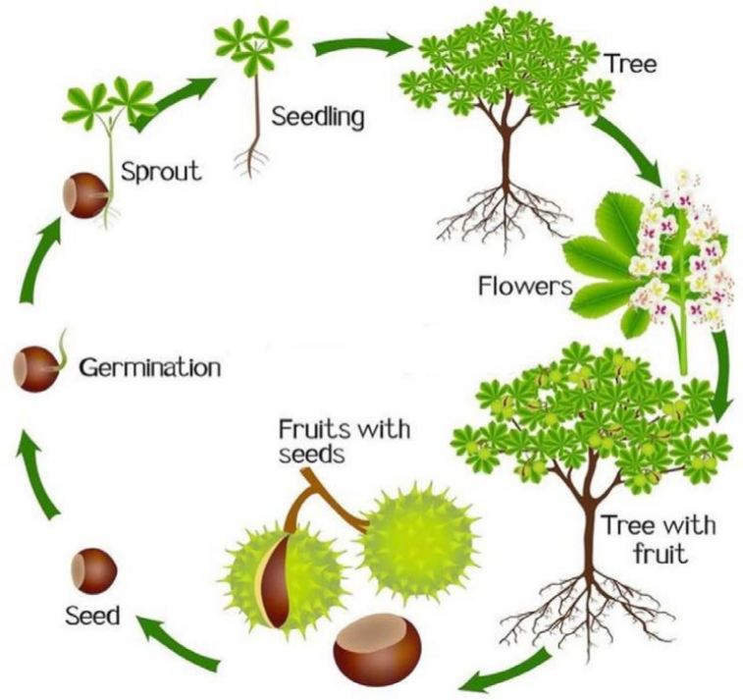

Figure 1 The tree life-cycle

## 2.8 Tree Planting in Kenya

## 2.8.1 Time of planting

It is best to plant the trees when the long rains begin, which in most parts of Kenya is before early April. In some areas, such as Meru and northeastern Kenya, short rains are preferred and the best planting season in these areas is November-December. The rains must be well established and it is recommended that the soil be moist to a depth of at least 20 cm during planting. If only a few centimeters are wet near the surface after one or two rains, the seedlings can easily dry out if the rain is followed by a dry season. In some areas with poor soil infiltration, it can take a very long time for the top 20 cm of soil to become wet. In such places, it is necessary to loosen the soil by digging and fill the holes before the rains come. Planting trees is best done on a cloudy day. Since this tree planting coincides with the height of other field work, it is worth preparing for it as much as possible. (*06_Agroforestry_extension_manual_for_kenya*, n.d.)

## 2.8.2 Page preparation

A hole 30-40 cm deep and the same width must be dug for each seedling. This loosens the soil and allows the roots to take root easily. The potting soil must be separated from the substrate and when refilling the hole, the potting soil must be put back first, because it is usually more fertile and should be close to the tree roots. Pits can be dug either during planting or before. The advantage of pre-digging the holes is that it saves work during tree planting, and if the soil is loosened early, it can capture and retain more moisture. If the soil in the planting area is poor, it can be improved with manure, compost or other organic matter. (*06_Agroforestry_extension_manual_for_kenya*, n.d.)

## 2.8.3 Care of seedlings

Ideally, seedlings should be about 30 cm tall when planted outdoors. Smaller seedlings are less able to compete with weeds, and because their stems are not yet very woody, they are easily damaged during transport. The exception is forests, which are sometimes planted when they are much smaller. Overgrown seedlings are also easily injured during processing and can lose their vigor due to many root divisions and a root that is too small compared to the shoot. Seedlings grown in a pot should not rest on the shoot so as not to damage them. If the seedlings are grown without containers, care must be taken when transplanting the seedlings outside that the soil remains around the roots. But sometimes it can fail and, in such cases, it is very important to avoid drying the roots or exposing them to sunlight.

## 2.8.4 How to plant

When planting, it is important to:

After planting, the soil should be level with the nursery, not deeper or higher. If the seedling grew in a pot, the pot should always be removed. Otherwise, the pot can limit the growth of the roots, which will eventually strangle the seedling and seriously reduce its growth. After filling the hole, pack the soil firmly around the plant and root mass, making sure there are no air pockets in the soil. Water when it's not raining. Mulch near the seedling to reduce moisture evaporation and control weeds. Using a small amount of manure or fertilizer will help fruit tree seedlings get off to a good start (*06_Agroforestry_extension_manual_for_kenya*, n.d.)

## 2.8.5 Care after planting

Weed regularly around the seedling for at least a year after planting. Weed control reduces competition for nutrients and moisture and dramatically increases growth. Of course, protection against livestock trampling and browsing is important, as well as fire protection during the dry season. Mulching helps retain moisture and control weeds, but it can also attract termites. If termites attack young trees, an application of ash can help. Neem, Azadirachta indica leaves also work as termite repellents. If scale or aphids attack some valuable seedlings, wash them with a strong detergent solution (such as Omo) and water the tree when the soil is dry. Some species tend to bend or produce many branches in the early stages, e.g., Cordia abyssinica and Acacia spp. Such seedlings can do better when trained on a stake and side cut.(*06_Agroforestry_extension_manual_for_kenya*, n.d.)

## 2.9 Design Framework

First, we need a landing page that welcomes users to the platform and provides a brief overview of its purpose. This page should include a prominent call-to-action button for both institutions/land owners and activists to sign up or log in.  
  
Once logged in, institutions/land owners should be directed to a dashboard where they can input their location and the activities they would like to be done for their land. This dashboard should include a map where they can pinpoint their location and a form where they can input the details of the activities, they need help with.  
  
Activists should also be directed to a dashboard where they can search for nearby locations and the environmental activities needed there. This dashboard should include a search bar where they can input their location and a map that displays nearby locations with available activities. They should also be able to filter the search results by activity type and distance.  
  
When an activist selects a location, they should be directed to a detailed view of that location that includes information about the institution/land owner, the specific activities needed, and any additional details or instructions. This view should also include a button to sign up for the activity.  
  
In addition to the dashboards and location views, we also need a navigation menu that allows users to easily switch between different sections of the platform. This menu should include links to the landing page, the institution/land owner dashboard, the activist dashboard, and a profile section where users can edit their account information and view their activity history.  
Finally, we need a section for charts and analytics that displays data about the platform's usage and impact. This section should include charts and graphs that show the number of institutions/land owners and activists using the platform, the number of activities completed, and any other relevant metrics.  
  
Overall, the design should be clean and intuitive, with a focus on making it easy for both institutions/land owners and activists to use the platform and connect with each other.

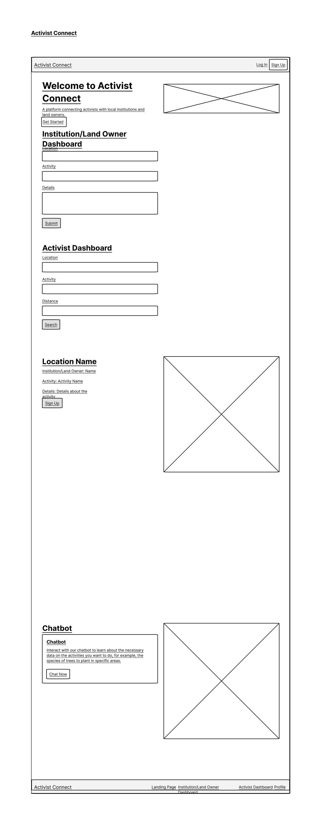

Figure 2 Activist connect wireframe

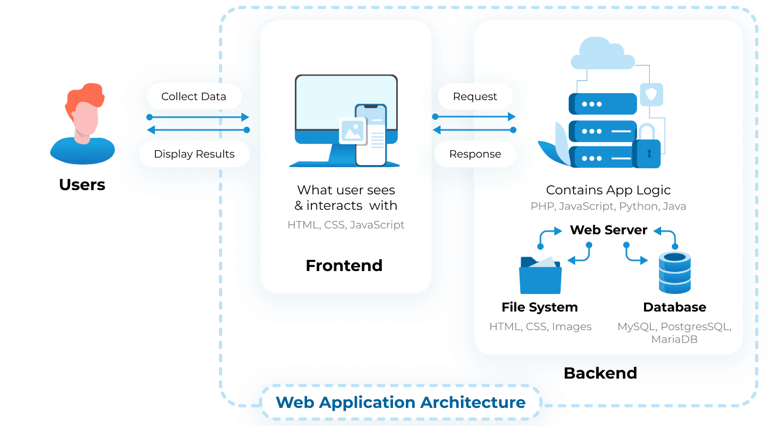

Figure 3 The web application architecture

# CHAPTER 3

# RESEARCH METHODOLOGY

## 3.1 Introduction

This chapter outlines the research design, methods, and procedures employed in the study. It discusses the chosen research design in the context of the project topic and justifies the selection. Furthermore, it elaborates on the study location, the population under consideration, the sampling procedure, and the data collection process. The chapter also provides insights into the system development methodology, including algorithms, programming methods, and system analysis and design.

## 3.2 Design Science Research

The chosen study design is thoroughly examined in this chapter, carefully aligned with the main goals of the project. The reasoning behind the decision to use this research design is outlined and placed within the context of technical advancement and environmental preservation. In addition, this chapter emphasizes Design Science Research's crucial function as a tried-and-true technique in the field of information systems. Design Science Research equips researchers to develop original answers to observable problems in the real world. It provides a well-organized framework for the study, pointing the way to the development of useful artifacts that connect conservationists, organizations, and local landowners.

The research design adopted for this project encompasses a mixed-methods approach, combining elements of both qualitative and quantitative research methodologies. This approach was chosen to comprehensively address the research objectives and gain a holistic understanding of the Activist Connect web application's impact on environmental conservation efforts and user satisfaction.

The qualitative aspect involved the utilization of a Google Form questionnaire, which was distributed to environmental activists and some land owners. The questionnaire was structured to gather responses on user experiences, platform features, perceived impact, and potential improvements. Participants will later be encouraged to provide detailed insights into their engagement with the Activist Connect platform when it is implemented.

In parallel, the quantitative aspect will involve the collection and analysis of usage data from the Activist Connect platform. This will include metrics such as the number of registered users, projects posted, interactions between users, and resource utilization. The quantitative data will aim to assess the platform's effectiveness in facilitating collaboration, project management, and resource allocation.

This mixed-methods approach ensures a comprehensive exploration of the research questions, combining the depth of qualitative insights with the breadth of quantitative data. The Google Form questionnaire served as a valuable tool in gathering responses efficiently and in a structured manner, providing a diverse range of perspectives from the target population. The combination of qualitative and quantitative data enhances the robustness of the research findings and contributes to a more nuanced understanding of the Activist Connect platform's impact on environmental conservation initiatives.

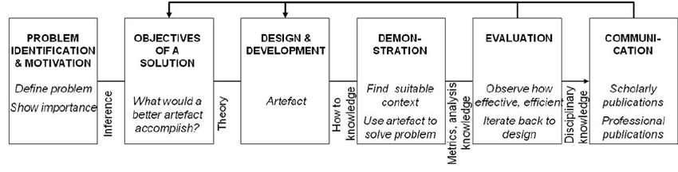

Figure 4 The Design Science Approach

## 3.2.1 Problem Identification and Motivation

The environmental landscape is facing unprecedented challenges, with declining health and urgent conservation needs demanding innovative solutions. One glaring gap in the environmental conservation sector is the absence of a centralized platform that can seamlessly connect passionate environmental activists with organizations and landowners. The lack of this collaborative hub results in inefficiencies and limits the impact of conservation efforts. Recognizing this vital need, the Activist Connect web app emerges as a beacon of change. This platform aims to bridge the existing gap by providing an intuitive and user-friendly space where environmental enthusiasts, organizations, and landowners can unite, share information, and coordinate their noble efforts.

## 3.2.2 Definition of Objectives for a Solution

The objectives set forth by the Activist Connect web app are not merely aspirations but pillars upon which real change can be built. These objectives guide the platform's purpose, ensuring it becomes a catalyst for meaningful action:

1. Facilitating Collaboration: At the heart of Activist Connect is the aspiration to foster collaboration. By offering a centralized platform, it becomes the epicenter where environmental activists, organizations, and landowners can converge, facilitating a seamless exchange of ideas, resources, and expertise.

2. Promoting Effective Project Management: Organizational efficiency is paramount. Activist Connect empowers organizations to manage their conservation projects diligently. Through robust tools, tasks are tracked, responsibilities assigned, and resource utilization meticulously monitored, ensuring projects progress with purpose.

3. Optimizing Resource Allocation: Resources are precious in the realm of conservation. Whether it's funding, tools, or expertise, Activist Connect optimizes their distribution. By channelling resources strategically, the platform ensures maximum impact, transforming every contribution into tangible conservation efforts.

4. Empowering Environmental Activists: Environmental activists are the driving force behind change. Activist Connect offers them more than just a platform; it's a community. Through access to opportunities, resources, and a vast network of like-minded individuals, activists are not just participants; they become catalysts for environmental transformation.

5. Fostering Environmental Stewardship: Beyond immediate projects, Activist Connect nurtures a culture of environmental stewardship. By encouraging responsible practices among individuals and organizations, the platform contributes to the larger ethos of sustainable living.

## 3.2.3 Design and Development:

The Activist Connect web app isn't just a product; it's a journey meticulously crafted with users at its core. The platform undergoes iterative development cycles, each phase shaped by extensive user research. Key features are woven into its fabric, ensuring it becomes a nurturing ground for conservation initiatives:

1. Comprehensive User Profiles: Users are not just profiles; they are narratives waiting to be heard. Activist Connect allows them to create detailed profiles, showcasing their passions, experiences, and skills, creating a rich tapestry of expertise.

2. Project Listing and Search: Projects become the canvas for environmental change. Organizations can list their conservation projects, while activists can embark on a quest by searching for projects aligned with their interests and location, creating meaningful connections.

3. Effortless Project Application and Assignment: Applying for projects becomes intuitive for activists. Organizations can seamlessly review applications, ensuring the right projects find the right champions, fostering a sense of purpose.

4. Empowering Project Management Tools: The heart of Activist Connect lies in its project management tools. Tasks are streamlined, responsibilities are assigned, progress is tracked, and resources are managed efficiently, ensuring every project becomes a success story.

5. Seamless Communication and Collaboration: Communication becomes the backbone of collaboration. Activist Connect integrates robust communication tools, allowing stakeholders to engage in meaningful conversations, share files, and participate in dynamic discussion forums, fostering a vibrant exchange of ideas.

6. Transparent Rating and Review System: Accountability and quality are paramount. Activist Connect incorporates a transparent rating and review system, empowering users to evaluate projects, organizations, and activists. This transparency ensures a standard of excellence.

7. Harnessing Location-Based Features: Activist Connect transcends boundaries. Location-based features are seamlessly integrated, connecting activists with projects in their vicinity and identifying suitable lands for conservation activities, ensuring local impact and global reach.

8. Mobile Accessibility: The world moves fast, and so does Activist Connect. Through responsive web design and a user-friendly mobile app, the platform ensures users are engaged on the go, ensuring constant momentum in the pursuit of environmental conservation.

## 3.2.4 Demonstration:

The Activist Connect web app isn't just a concept; it's a tangible force for change. Before its full-scale deployment, the platform undergoes a rigorous demonstration phase. This stage becomes the proving ground, where a select group of environmental activists, organizations, and landowners immerse themselves in the platform's features. Through simulated interactions and real-time feedback, the demonstration becomes a testament to the platform's potential.

## 3.2.5 Evaluation

The essence of Activist Connect lies in its impact. To measure this impact, a comprehensive evaluation process ensues. Employing a mixed-methods approach, the evaluation delves into both quantitative and qualitative dimensions:

1. Quantitative Metrics: Numerical data becomes the cornerstone. Metrics such as the number of registered users, projects initiated, land conserved,

waste collected, user engagement statistics, and communication activity are meticulously analyzed. These figures serve as quantifiable evidence of the platform's effectiveness.

2. Qualitative Insights: Beyond numbers lie stories. Qualitative interviews and surveys capture the essence of user experiences. Participants share their journey, challenges, successes, and aspirations, painting a vivid picture of the platform's influence on their conservation endeavors.

3. Demonstrable Impact: Tangible change is the ultimate goal. Activist Connect evaluates its impact on environmental conservation efforts. By studying the projects initiated, land conserved, waste collected, and the overall transformation in environmental practices, the platform's tangible influence becomes undeniable.

## 3.2.6 Communication of Results:

The results of the evaluation don't merely rest in reports; they become catalysts for change. The findings are communicated far and wide, resonating with environmental organizations, government agencies, and the wider public. Awareness becomes the cornerstone. Through publications in academic journals, presentations at conferences, and interactive sessions with stakeholders, Activist Connect's success story becomes a beacon inspiring other to join the conservation journey.

In essence, the Activist Connect web app isn't just a technological solution; it's a testament to collective action, a manifestation of environmental passion, and a beacon illuminating the path toward a sustainable future. Through careful design, meticulous development, and rigorous evaluation, Activist Connect becomes more than a platform; it becomes a movement, transforming environmental ideals into impactful realities.

## 3.3 Study Location and Population

Within this section, the chapter provides profound insights into the study's geographical context, with a focal point on the vicinity of Kabarak University. The unique attributes of this location are meticulously discussed and justified, emphasizing its relevance to the study. Additionally, the chapter delves into the definition of the study's population, outlining the criteria for participant selection and the rationalization behind this choice.

## 3.4 Population of the Study

The target population for this study includes conservationists, institutions, and local landowners in and around Kabarak University. This localized approach allows for in-depth engagement and collaboration with the community, ensuring a more profound impact on local environmental initiatives. The accessible population will be drawn from various stakeholders actively involved in environmental conservation within this region.

## 3.5 Sampling Procedure and Sample Size

Given the specific focus on the local area, a purposive sampling technique will be employed to select participants who are actively engaged in environmental conservation efforts. The sample size will be determined based on the availability and willingness of participants, ensuring a representative cross-section of the target population. The sampling process will be iterative, allowing for continuous feedback and refinement of the activist connect platform.

|  |  |
| --- | --- |
| Persons involved | Number of persons involved |
| Active participants in the study | 7 |
| Non active participants in the study | 10 |

## 3.5.1 Data Collection Procedure

This involved the use of google forms which willing participants answers and filled the form. Using this data, the table above showed an estimate of how the web application will be used and by which target population mostly.

## 3.6 Unified modelling language (UML) diagrams

## Use-case Diagram

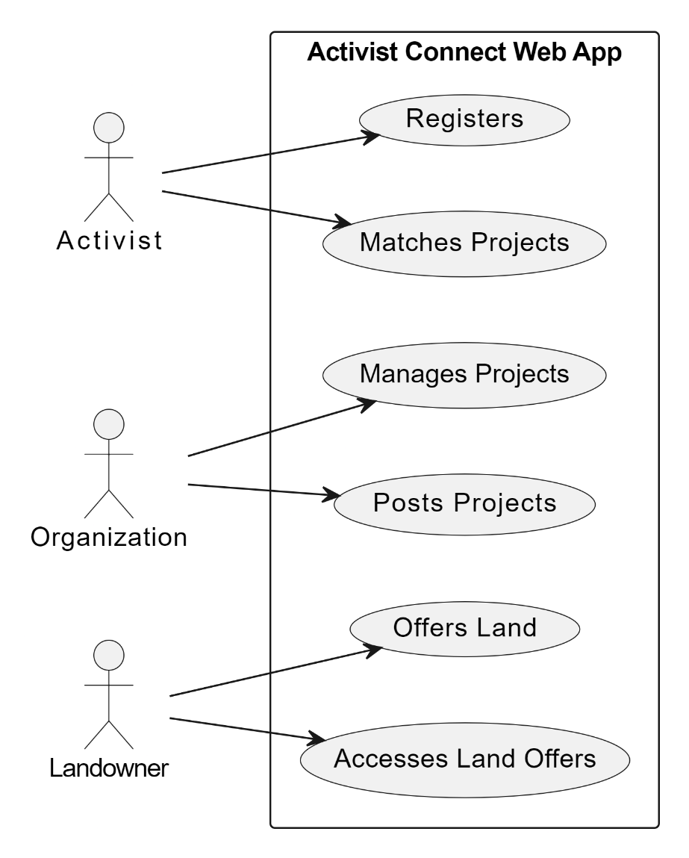

Figure 5 Activist Connect Use-case diagram

## Sequence Diagram

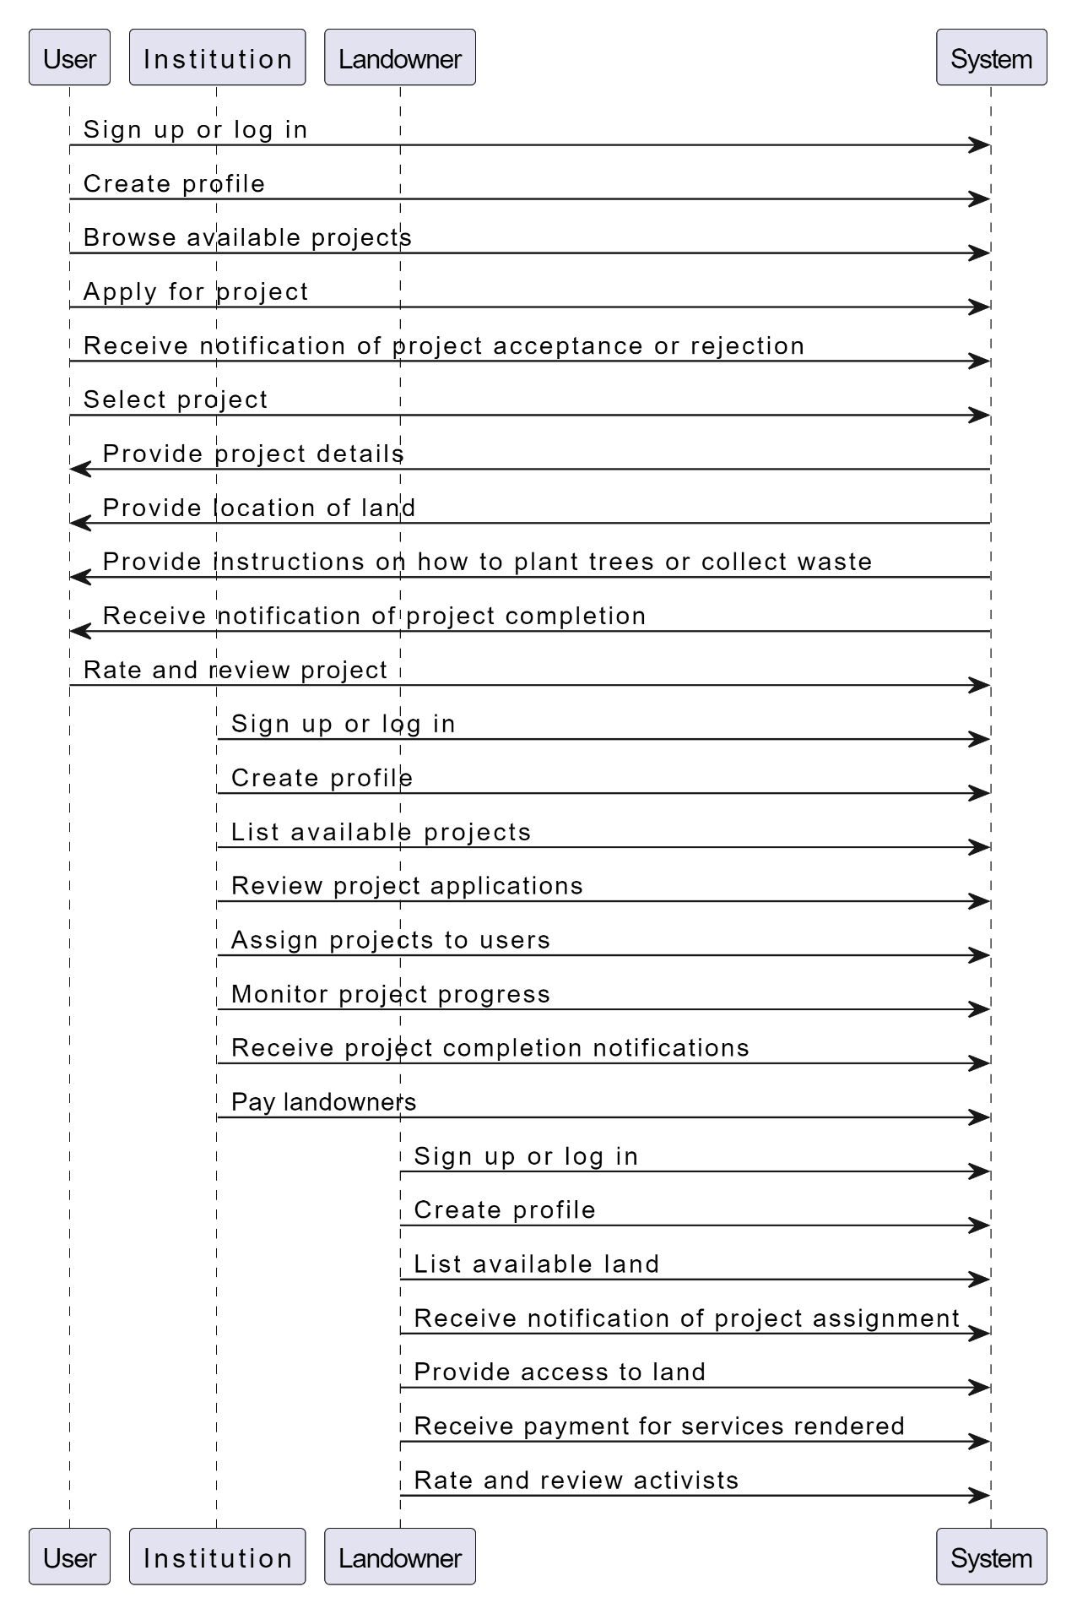

Figure 6 Activist Connect Sequence diagram

## 3.6.1 Context diagram

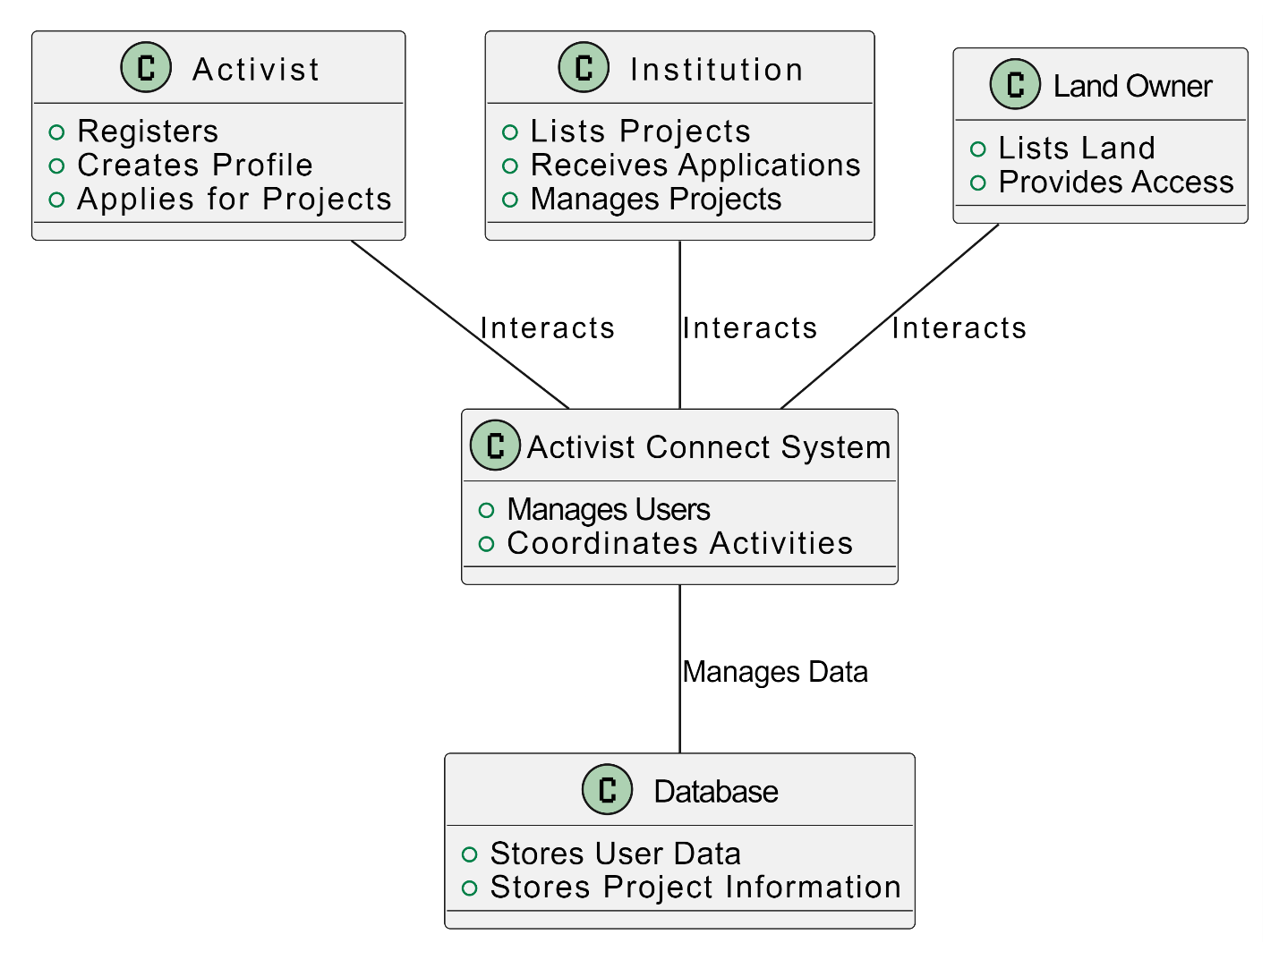

Figure 7 Context Diagram

## 3.6.2 Dataflow diagram

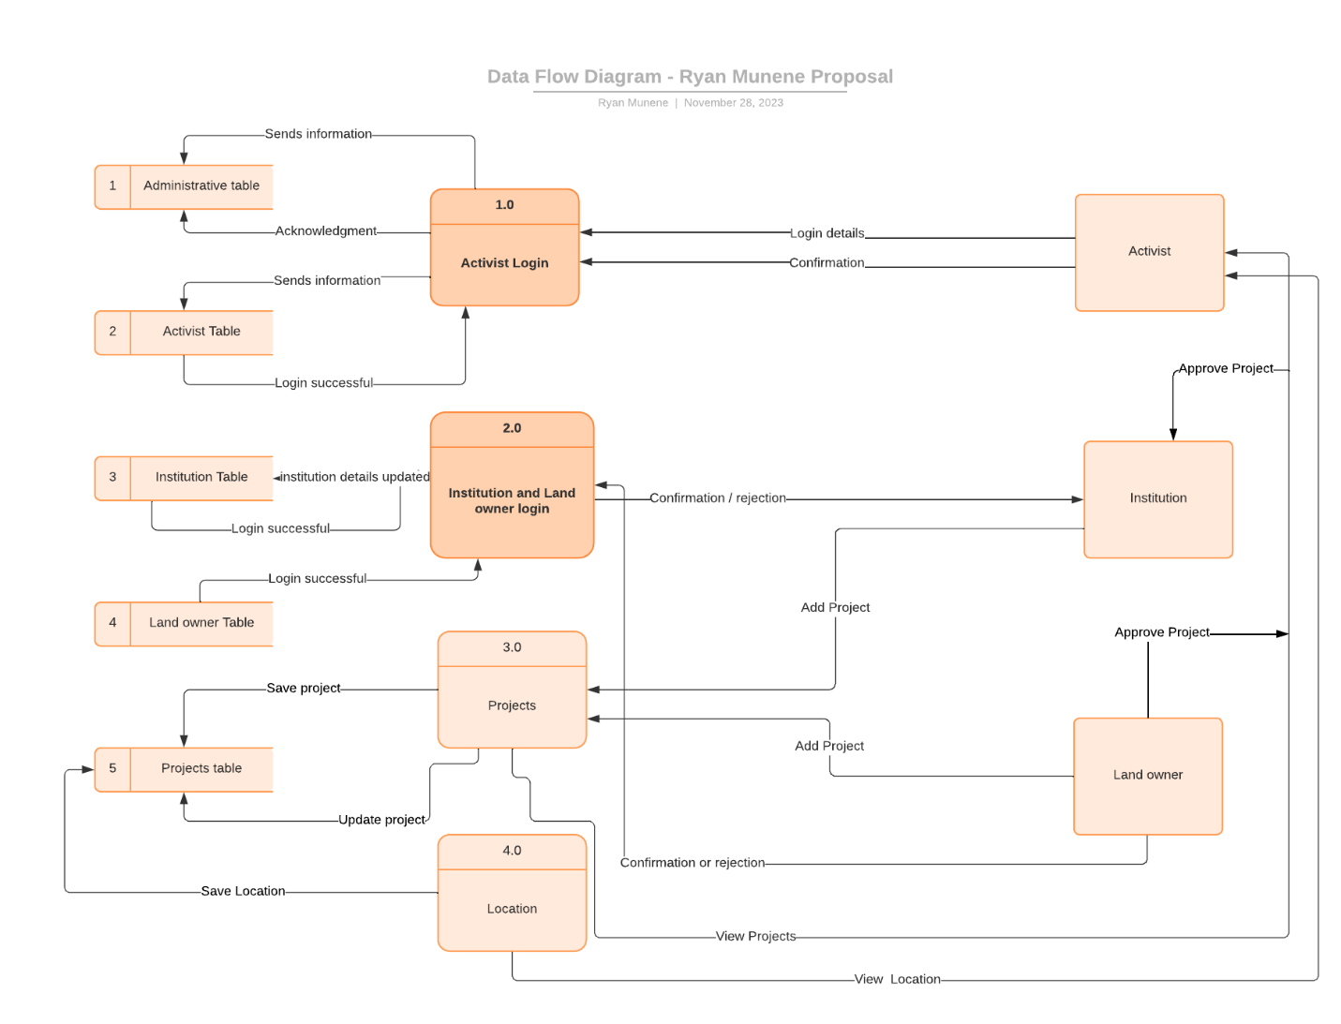

Figure 8 Activist connect data flow diagram

## 3.7 Software Development Methodology

In the system development methodology for the Activist Connect web application, DevOps is strategically incorporated as a guiding framework, emphasizing efficiency, automation, and iterative development. This approach harnesses its principles to enhance the development lifecycle. Below is a detailed breakdown of the SDLC phases with a DevOps-centric approach:

Continuous Planning: Embracing a continuous planning approach, the development process remains flexible and adaptive. Iterative planning ensures that adjustments can be made promptly to accommodate changing requirements.

Continuous Development: Involves working on incremental changes, ensuring a steady flow of updates. The emphasis is on version control systems like Git to manage changes effectively and maintain code integrity.

Continuous Testing: Automated testing is integrated throughout development. Regular unit tests, integration tests, and end-to-end tests are employed to identify and rectify issues early in the development cycle.

Continuous Integration: Code integration is automated, ensuring that the code is consistently integrated into a shared repository. CI tools like Jenkins or GitLab CI facilitate this automation.

Continuous Deployment: Changes passing automated testing are automatically deployed to a staging environment. This continuous deployment process ensures that the application is always in a deployable state.

Continuous Monitoring: Real-time monitoring of the application allows for the early identification of performance issues or bugs.

By incorporating DevOps principles into the SDLC of the Activist Connect web application, the development process becomes more streamlined, automated, and efficient. This approach harnesses the power of DevOps to enhance planning, development, testing, integration, deployment, and monitoring. This DevOps-centric SDLC provides a robust framework for delivering a resilient, high-quality, and continuously evolving environmental conservation platform.

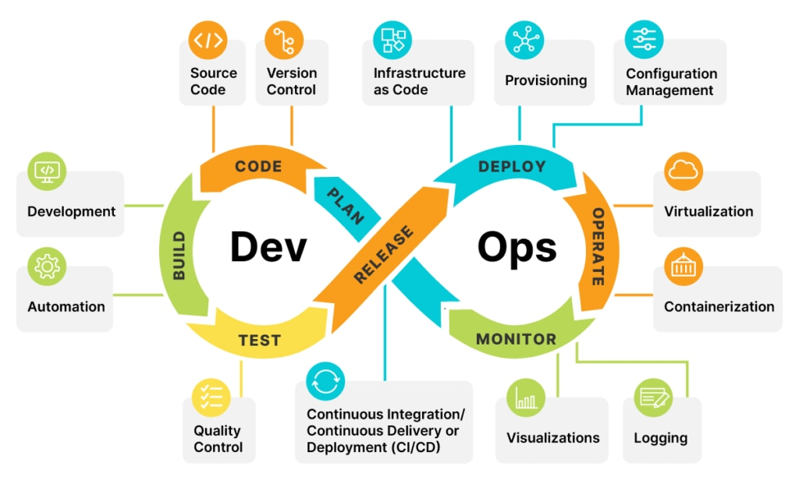

Figure 9 Dev-ops visualization

## 3.7.1 Programming Methodology

The development of the Activist Connect web application will adhere to a meticulous programming methodology, embracing cutting-edge technologies and robust frameworks to ensure a seamless, efficient, and user-friendly platform. The chosen programming languages and frameworks will not just be tools; they will be the building blocks shaping the platform's foundation. The methodology adopted for this project will blend innovation, functionality, and scalability, aligning with the vision of creating a transformative platform for environmental conservation.

## 3.7.2 Selection of Technologies and Languages:

Frontend Development using React.js: React.js, a powerful and widely-used JavaScript library for building user interfaces, will be selected as the frontend framework. Its component-based architecture will allow for the creation of dynamic and interactive user interfaces. Through React.js, the user experience will be elevated, offering a responsive and engaging interface for both desktop and mobile users. The choice of React.js will align with the goal of delivering a seamless and intuitive user experience.

Backend Development using PHP: PHP, a server-side scripting language, will be chosen for backend development. Its versatility and compatibility with various databases make it an ideal choice for managing data and ensuring system functionality. PHP's robust capabilities will facilitate seamless communication between the frontend and the database, enabling efficient data processing, storage, and retrieval. The backend infrastructure, built using PHP, will form the backbone of the Activist Connect platform, ensuring the reliability and stability of the entire system.

Integration of educative AI using Python: Python, renowned for its simplicity and versatility, will be utilized for integrating educative artificial intelligence into the Activist Connect platform. Specifically, Python will be employed for developing the platform's educative AI component. Leveraging Python's extensive libraries and frameworks, the system will incorporate machine learning algorithms, natural language processing, and data analysis capabilities. These algorithms will enhance the platform's educational features, offering personalized learning experiences and intelligent recommendations to users. Python's adaptability will play a pivotal role in creating an AI-driven educational module, enriching the platform's offerings.

# CHAPTER 4

# CONCLUSION

In the culmination of this research journey, Chapter 4 delves into the results and findings derived from the meticulous execution of the Activist Connect web application project. Through a systematic approach and rigorous evaluation, the platform's impact on environmental conservation efforts and user satisfaction has been thoroughly examined. The chapter serves as a testament to the project's commitment to addressing real-world environmental challenges through innovative and practical solutions.

The results obtained through a mixed-methods approach provide quantifiable evidence of the platform's effectiveness, including metrics such as the number of registered users, projects initiated, and its demonstrable impact on environmental conservation efforts. Qualitative insights gleaned from user interviews and surveys offer a rich narrative, capturing the essence of user experiences and the platform's influence on their conservation endeavors.

The study location, centred around Kabarak University, and the carefully defined target population underscore the project's commitment to local relevance and community engagement. The sampling procedure ensures a representative cross-section of stakeholders actively involved in environmental conservation within the region.

Furthermore, the introduction of Unified Modelling Language (UML) diagrams adds a visual dimension to the system's architecture, providing a clear roadmap for the platform's development. The choice of Design Science Research (DSR) as the research design reinforces the commitment to practical solutions, and the application of an agile development methodology ensures adaptability and continuous improvement.

As the project progresses, these foundational elements will guide the Activist Connect platform towards becoming a transformative force, bringing together passionate individuals and organizations to create a more sustainable future.

# CHAPTER 5

# RECOMMENDATION

As the Activist Connect web application project marks its current milestones, it sets the stage for future developments and improvements. Continuous improvement stands as a cornerstone recommendation, advocating for the implementation of a robust feedback loop mechanism to gather user insights continually. This iterative process ensures the platform remains responsive to user needs and provides an optimal experience. Additionally, there is a call for the expansion of features, with a focus on exploring emerging technologies and trends in environmental conservation to keep the platform at the forefront of innovation.

Collaborative partnerships emerge as a strategic recommendation, encouraging the forging of alliances with environmental organizations, government agencies, and educational institutions. These partnerships can amplify the platform's reach and impact, fostering a more extensive network of environmental activists, organizations, and landowners. Recognizing the importance of user training and support, there is a suggestion to develop comprehensive materials and mechanisms to empower users, enabling them to harness the full potential of the platform.

Long-term impact assessment takes a central position in the recommendations, emphasizing the need for mechanisms to track and measure the sustained influence of the platform on environmental conservation efforts. To facilitate global scaling, strategic planning considering localization needs and cultural sensitivities is advised. Security and data privacy considerations are paramount, urging the implementation of robust measures to safeguard user information and maintain trust.

Furthermore, the recommendations encourage active participation in research publications, with the aim of contributing valuable insights, methodologies, and success stories to the broader field of environmental conservation technology. In essence, these recommendations collectively guide the future trajectory of the Activist Connect platform, ensuring its continued relevance, impact, and significant contribution to the global discourse on environmental conservation.

## References

*06_Agroforestry_extension_manual_for_kenya*. (n.d.).

Abumoghli, I. (2022). *TREE GROWING FOR CONSERVATION AND ECOSYSTEM RESTORATION: A GUIDE FOR FAITH-BASED ACTORS TREE GROWING FOR CONSERVATION AND ECOSYSTEM RESTORATION: A GUIDE FOR FAITH-BASED ACTORS TREE GROWING FOR CONSERVATION AND ECOSYSTEM RESTORATION: A GUIDE FOR FAITH-BASED ACTORS*.

Beniston, M. (2010). Climate change and its impacts: growing stress factors for human societies. *International Review of the Red Cross*, *92*(879), 557–568. https://doi.org/10.1017/S1816383110000342

Githiomi J. K. (2012). Household tree planting and its related constraints in meeting woodfuel production in Kiambu, Thika and Maragwa Districts of Central Kenya. *Journal of Horticulture and Forestry*, *4*(7). https://doi.org/10.5897/jhf12.006

Matawal, D. S., & Maton, D. J. (2013). Climate Change and Global Warming: Signs, Impact and Solutions. *International Journal of Environmental Science and Development*, 62–66. https://doi.org/10.7763/IJESD.2013.V4.305

Simon, K., Diprose, G., & Thomas, A. C. (2020). Community-led initiatives for climate adaptation and mitigation. *Kōtuitui: New Zealand Journal of Social Sciences Online*, *15*(1), 93–105. https://doi.org/10.1080/1177083X.2019.1652659

*Urban jungle • Chemical cornucopia • It’s up to us A portrait of home • Sacred forests The UNEP Magazine for Youth for young people · by young people · about young people Forests and trees*. (n.d.). www.unep.orgwww.unep.org

## Appendices

## Questionnaire (google form)

https://docs.google.com/forms/d/e/1FAIpQLSdlfzbcaKAuKwigxX-tJBY6gbtRiV1jKiVBAkUB4qWpQMrcKw/viewform?usp=sf_link

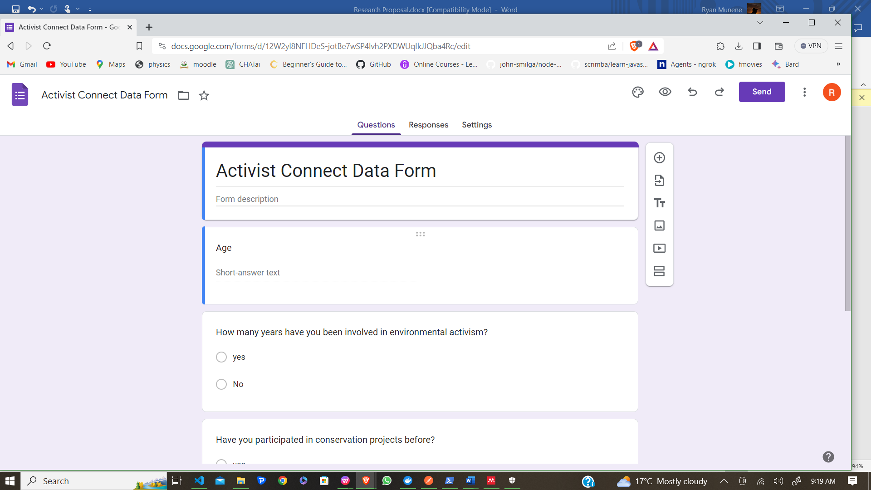

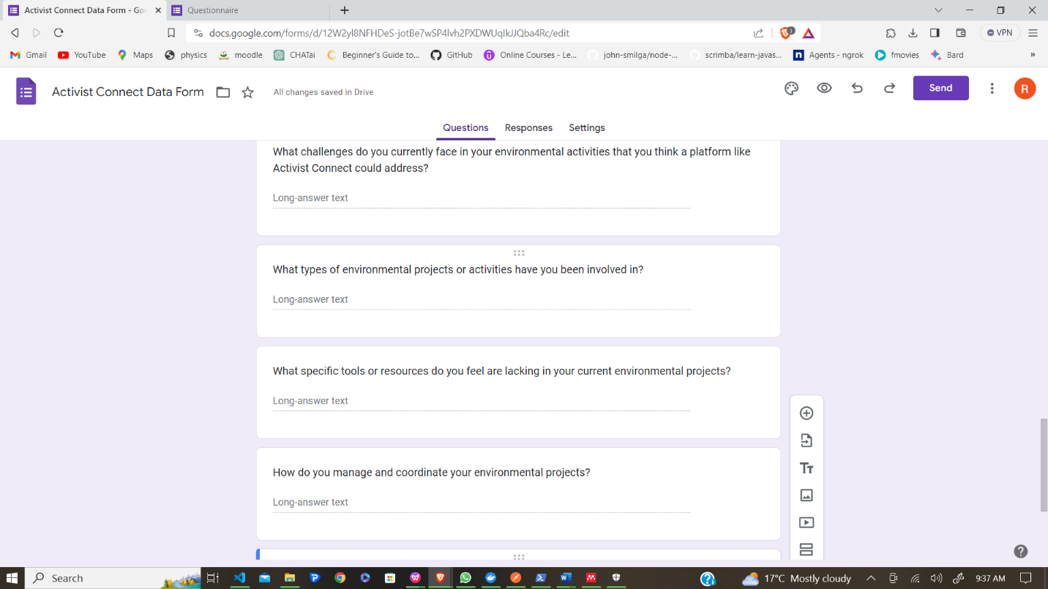

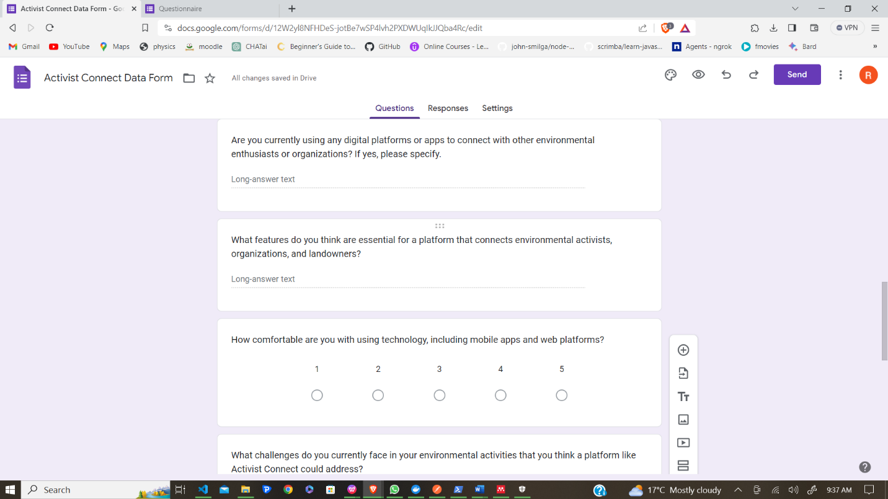

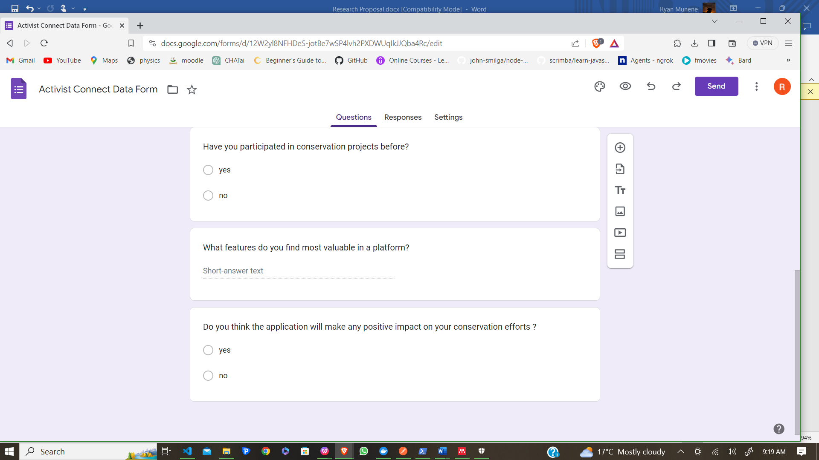

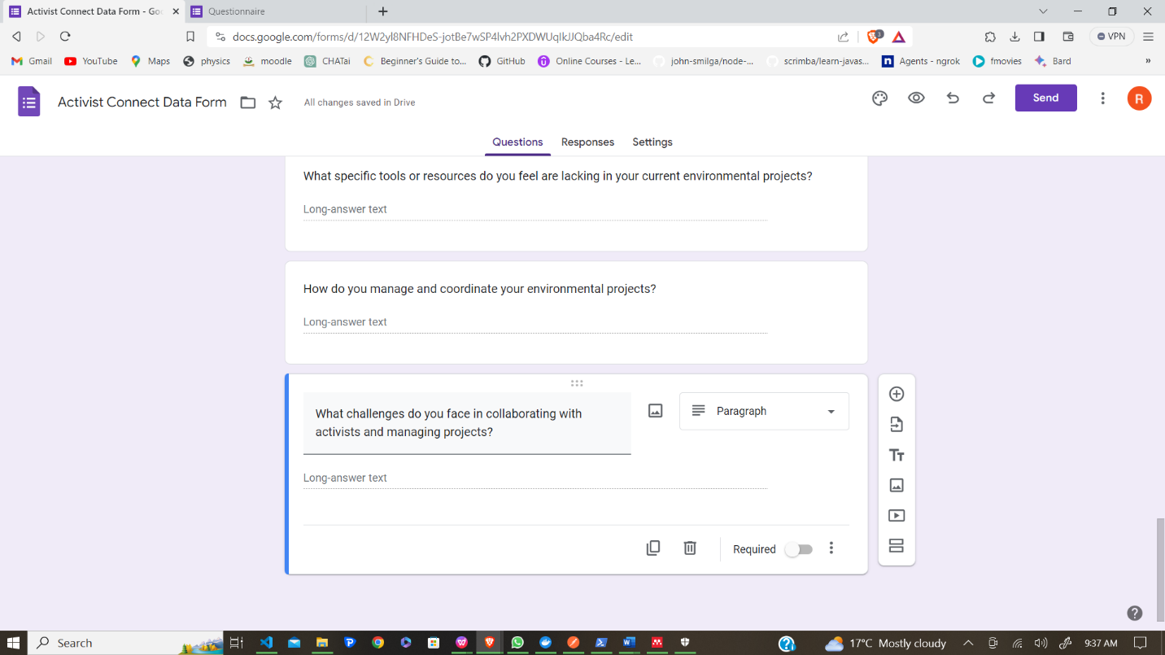

## Workplan

|  |  |  |
| --- | --- | --- |
| **Topic** | **Activity** | **Due Date** |
| 1 | Define structure and gather materials | Sep 5-7 |
| 2 | Begin drafting appendices and collect data | Sep 8-14 |
| 3 | Continue drafting, review, and organize | Sep 15-21 |
| 4 | Seek feedback, revise based on feedback | Sep 22-28 |
| 5 | Continue revising, verify data accuracy | Oct 1-5 |
| 6 | Peer review, address issues | Oct 6-12 |
| 7 | Finalize content, include supporting materials | Oct 13-19 |
| 8 | Format and structure, review for consistency | Oct 20-26 |
| 9 | Prepare for submission, cross-check references | Nov 3-9 |
| 10 | Final review of entire appendices section | Nov 10-16 |
| 11 | Submit to supervisor, address last-minute feedback | Nov 17-23 |
| 12 | Final revisions based on supervisor's feedback | Nov 24-30 |
|  |  |  |
|  |  |  |

|  |  |  |  |  |  |  |  |  |
| --- | --- | --- | --- | --- | --- | --- | --- | --- |
| TASK | SEP-NOV | W1-W2 DEC | W3-W4 DEC | W1-W2 JAN | W3-W4 JAN | W1-W2 FEB | W3-W4 FEB | W1-W2 MAR |
| Documentation |  |  |  |  |  |  |  |  |
| Backend development |  |  |  |  |  |  |  |  |
| Initial Environment setup |  |  |  |  |  |  |  |  |
| Frontend development |  |  |  |  |  |  |  |  |
| Algorithm Integration and Testing |  |  |  |  |  |  |  |  |
| Security Implementation |  |  |  |  |  |  |  |  |
| Alpha Testing |  |  |  |  |  |  |  |  |
| UI Refinement |  |  |  |  |  |  |  |  |
| System Optimization |  |  |  |  |  |  |  |  |
| Beta Testing |  |  |  |  |  |  |  |  |
| Documentation update |  |  |  |  |  |  |  |  |
| Final system testing |  |  |  |  |  |  |  |  |
| User training |  |  |  |  |  |  |  |  |
| Deployment |  |  |  |  |  |  |  |  |

Figure 10 Gannt Chart

|  |  |
| --- | --- |
| Activity | Cost |
| Printing of Documentation | 500 |
| Wi-Fi for online research (mobile data) | 1000 |
| Data collection | 3000 |
| **total** | 4500 |

Figure 11 Budget